**Functions in C++**

A function is a set of statements that take inputs, do some specific computation,and produce output. The idea is to put some commonly or repeatedlydone tasks together and make a **function**so that instead of writing the same code again and again for different inputs, we can call the function.  
In simple terms, a function is a block of code that only runs when it is called.

**Syntax:**

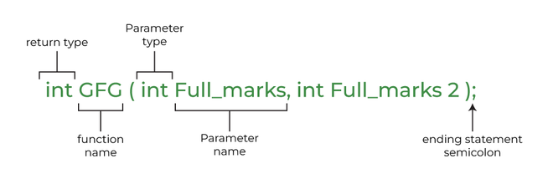

**Example:**

C++

// C++ Program to demonstrate working of a function

#include <iostream>

using namespace std;

// Following function that takes two parameters 'x' and 'y'

// as input and returns max of two input numbers

int max(int x, int y)

{

if (x > y)

return x;

else

return y;

}

// main function that doesn't receive any parameter and

// returns integer

int main()

{

int a = 10, b = 20;

// Calling above function to find max of 'a' and 'b'

int m = max(a, b);

cout << "m is " << m;

return 0;

}

**Output**

m is 20

Explanation: - As the maximum of 10 and 20 is 20 so, m will become 20.

**Why Do We Need Functions?**

* Functions help us in ***reducing code redundancy***. If functionality is performed at multiple places in software, then rather than writing the same code, again and again, we create a function and call it everywhere. This also helps in maintenance as we have to change at one place if we make future changes to the functionality.
* Functions make code ***modular***. Consider a big file having many lines of code. It becomes really simple to read and use the code if the code is divided into functions.
* Functions provide ***abstraction***. For example, we can use library functions without worrying about their internal work.